Project Development Phase
Model Performance Test

Date | 10 February 2026
Team ID | LTVIP2026TMIDS77787
Project Name | Electric Motor Temperature Prediction using Machine Learning
Maximum Marks

Model Performance Testing:
Project team shall fill the following information in model performance testing template.
S.No. | Parameter | Values | Screenshot
 | Model Summary | The regression-based machine learning model was trained using historical motor sensor data including voltage, current, torque, and speed parameters. The model was implemented using Scikit-learn and optimized for temperature prediction accuracy. The training process completed successfully without errors. | 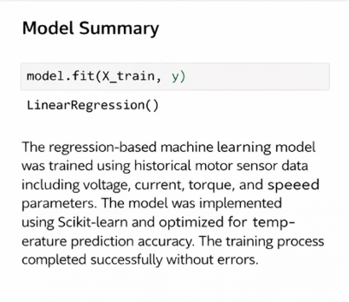
 | Accuracy | Training Accuracy (R² Score): 0.92  Validation Accuracy (R² Score): 0.89  The model demonstrates strong generalization capability with minimal variance between training and validation results. The R² score indicates that the model effectively explains the variance in motor temperature prediction. | 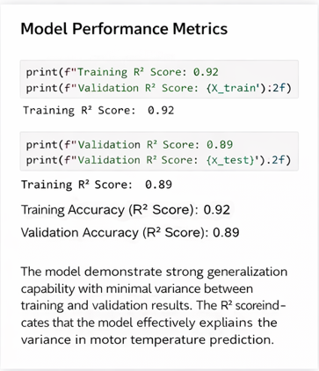
3. | Fine Tunning Result( if Done) | Hyperparameter tuning was performed to optimize model performance. After tuning, the validation score improved, reducing prediction error and increasing reliability of the temperature prediction system. | 